**Blade Runner (1982)**

*Introduction*

Blade Runner is a science fiction film by Ridley Scott based on the novel “Do Androids Dream of Electric Sheep?” by Philip K. Dick.

While initially presenting during the opening as a 70s/80s action film, it quickly proves otherwise to be a deep and dramatic exploration of what it means to be a human.

Set in Los Angeles 2019, 37 years after the film’s release, the city (and much of the world) is presented is a dystopian over-polluted city. Los Angeles is shown as being populated by many Asian peoples. The unique language of LA called “Cityspeak” is a mix of Japanese, Spanish, German, Hungarian, Chinese and French. Other dialogue in the film is in Korean. Deckard and most of the other cast speak English, likely the official language of Los Angeles. The presence of massive Asian populations is a reference to the popular 80s idea that Japan would take over the United States as the dominant economy.

Replicants, organic “androids” created to fill roles such slave labour, hazardous exploration, and colonisation of planets beyond Earth. However, due to a revolt by a combat team of “Nexus-6” replicants, their presence on Earth has been deemed illegal and a special police force known as “Blade Runners” find and kill what are considered trespassing replicants with full authority of the law. These executions are known as “retirement”.

Replicants are generally not considered to be the same as humans despite being made up of the same organic material and genetic structure, but instead of being born as humans are and growing up as humans do, they are created as full adults and given memories that did not belong to them, artificial or belonging to another person. Equipped with greater strength, agility, intelligence, speed, and resilience. This advanced development process leaves them without the emotional responses of a normal human. The Nexus-6 replicants are given a failsafe in that they only have a four-year lifespan to prevent the development of empathic ability and thus making them appear no different to humans.

The identification of replicants is observed through the usage of a “Voight-Kampff” test which analyses emotional response to scenarios. It normally takes twenty to thirty cross referenced questions to identify a replicant, however as show by the prototype “Nexus-7” called Rachael, it took over one hundred to determine whether she was a replicant. As the replicants in the film appear to be experiencing pain, negative emotions and a fear of death — we are forced to consider If this is a “being” which should fall under the same ethical code protections afforded to humans.

**Key Issue 1 – Can we definitely distinguish between real humans and artificially engineered replicants. If no test (neither objective or subjectively introspective) can show this for certain – then is a given replicant that is indistinguishable from a human therefore a human?**

**Key Issue 2 – Memories and how, from a dramatic philosophy point, they cannot be trusted. As humans we tend to treat our memories as reasonably accurate accounts of past events but the film introduces the idea that memories can and may be implanted – therefore false or misleading.**

**Key Issue 3 – What would I take to fundamentally question your memoires and consider that they may be implanted because of a drug or mental conditioning.**

**Key Issue 4 – In the director’s cut of the film, Rachael is revealed to have a life longer than the 4 years of the Nexus-6 replicants however it’s unclear if it is similar or beyond that of a human. Therefore, is the scenario of escape at the close of the film therefore no longer a happy ever after?**

**Key Issue 5 – In the director’s cut of the film, there is the question as to if Deckard is a replicant. In that scenario what is the impact of his feelings for Rachael?**

**Key Issue 6 – Was it wrong to enslave the replicants, using them as forced labour given that they were of human-like appearance and had human-like thought process. What would need to be different to be ok to be used as slave labour – e.g. would we have the same doubts with mechanised robotic droids with limited thought process and emotions?**

**Key Issue 7 – If humans want replicants/androids to obey rules of human society, e.g. laws, should they be afforded the same right rights as humans. See self-driving cars – they are expected to follow human laws but are not considered living, let alone human, but they do not have physical or mental feelings like replicants.**

**Key Issue 8 – Would different groups such as vegan/vegetarians see replicants/androids differently to people who eat meat. What about religion, would someone who believes in a god, gods or has other spiritual beliefs.**

**Key Issue 9 – Tyrell Corporation is a monopoly in design and manufacture of replicants. Replicants are still technically considered robotic despite being organic, real life comparison can be drawn to our mechanical robots, except they are far more advanced.**

**Key Issue 10 – When a replicant kills someone it is considered murder. (under UK law only a human can commit murder, therefore replicants would be considered human under current UK law, and therefore their enslavement would also be illegal. See issue 6/7)**

**Key Issue 11 – Replicants are considered lower class. Disposable – think bomb disposal robot, combat drones. Pleasure replicants (Prostitute robots (are human prostitutes today considered lower class?)).**

Replicants in the film are firmly presented as being lower class, they are used as slaves and have virtually no rights, particularly on Earth where they are totally forbidden and are to be “retired” as soon as they arrive considering they are trespassing. They have no option to decide their own career and are produced to serve a single role. It is shown in the film that replicants can be “retrained”, as Zhora was “bred for a special kick murder squad. Retrained for political homicide.”. Though it is not mentioned what this involves, it could be some sort of education in the traditional sense, taking advantage of the powerful intellects of the replicants or more akin to brainwashing, forced to forget/unlearn one set of skills, and having another set of skills embedded into them. This could be achieved through modifying their memories. Some replicants, such as Pris, are designed to fill the role of “pleasure” for humans and potentially for replicants.

Relating to real life, artificial constructs such as machines, robots and artificial intelligences are almost certainly created to fill a specific role.

Washing machines provide a far more efficient method of washing clothes, a job that would take up to 15 hours for the whole process, which may have been done several times a week, before the advent of the automatic washing machines and dryers, a technology which is still developing to accommodate faster washing, more clothing materials and in a more energy efficient, environmentally friendly, compact design.

More advanced machines designed for more complex tasks are called robots, generally a machine is considered a robot if it is multipurpose, reprogrammable, has a high level of physical capability and high degree of automation or automatic functionality.

Robots today often fill roles such as:

High-risk bomb disposal, as human life is considered far more valuable than that of the machine. Bomb disposal robots are remotely controlled by a human (or team of human) operators assisted by the computer systems on board. The robot is not considered alive, so it is not as bad from an ethical perspective if something goes wrong and it is blown up.

Filling the role of factory assembly line workers, articulated industrial Robots can work faster for longer at a greater level of precision than their human counterparts. Work that includes consistent, predictable actions to build a well-documented item. For example, the welding of certain areas of a metal sheet, where a system of coordinates can be used to determine where welding should begin and end. Society does not consider these to be alive either, since they have no emotions, no capacity to think critically or deliberately, willingly, stray from their intended purpose. These robots do not have any rights or protections under the law, only their usage as industrial workplace equipment, they can work as long as they are able to, there is no 9-to-5 work schedule or Unions or labour laws. They can work until they are destroyed, something it would be considered, a moral abuse to do in today’s world.

As Pris is a “pleasure model” in the film, there exists attempts to create real life “sexbots” by giving sex dolls the ability to speak, make facial expressions, move their bodies and exhibit human like responses to sexual activity.

Further developments from this have led the idea of combining companion robots mainly targeted for the bereaved widows, the elderly and for single children, who maybe suffering from social isolation.

The goal is to create full companion robots who not only provide the sexual aspect but also the normal human interaction element. Early examples of this include “Samantha” a sex robot created by Synthea Amatus, equipped with artificial intelligence and sensors and mood settings which not all would be receptive to sexual activity. This includes a “family” mode in which it will talk about science, philosophy and tell jokes. These robots would serve as relief for people who are socially isolated for long periods such as long-distance truck drivers and oil rig workers, or for people who struggle with social interactions.

A.I (Artificial Intelligence) is a branch of computer science that is chiefly concerned with the design and construction of machines capable of performing tasks that typically require human intelligence. AI can be approached from multiple disciplinary roots, but the leading advancements come from machine learning and deep learning, something that is broad reaching across technology industry.

Machine Learning is focused on the development of systems which allow the application to access data and learn to use it for itself. This process begins with the machine observing data, such as example scenarios, direct experience or instruction sets, these are used to identify patterns in data which will allow decisions based on what the machine decides is the logical next step.

Deep Learning is a function of AI, and a subsection of Machine Learning which is designed to replicate the human brain’s way of processing data and creating patterns, and uses adaptive algorithms that improve with newly analysed data. For example, in image processing, a deep learning system maybe be able to identify faces, body actions, and certain environmental objects and conditions, such as sunshine and clouds.

The implementation of robots who appear and act like humans has the potential to cause benefit. As described earlier, the mental wellbeing for people experiencing social isolation, or to assist with those who may be uncomfortable with interacting with people on an ordinary or intimate level. Providing someone who can be programmed to not appear openly negative towards to someone may prove more accessible than a human.

Similar machines can also be used in a similar way to the replicants in Blade Runner, to fill roles that would require human intelligence, but more physical resilience, and potentially, similarly to the Blade Runner franchise, a lack of empathy to achieve such as hazardous exploration and repair works, or for warfare, now that the world’s leading powers have begun to consider the militarisation of space. Though the social impact of having mechanical life exist alongside that of humans, filling roles beyond that of traditional industrial robotics may lead to the rise of new mainstream movements in “robo-ethics”, which exist in a limited capacity already, particularly around medical and military usage of robots.

|  |  |
| --- | --- |
| Issue 1 |  |
| Issue 2 |  |
| Issue 3 |  |
| Issue 4 |  |
| Issue 5 |  |
| Issue 6 |  |
| Issue 7 |  |
| Issue 8 |  |
| Issue 9 |  |
| Issue 10 |  |
| Issue 11 | <https://www.reviewthis.com/questions-shopping-for-washer/>,  <https://thescrubba.com/blogs/news/how-people-used-to-wash-the-fascinating-history-of-laundry>,  <https://www.reviewthis.com/history-of-washing-clothes>  [https://www.mckinsey.com/business-functions/mckinsey-digital/our-insights/where-machines-could-replace-humans-and-where-they-cant-yet#](https://www.mckinsey.com/business-functions/mckinsey-digital/our-insights/where-machines-could-replace-humans-and-where-they-cant-yet), <https://www.sas.com/en_gb/insights/analytics/what-is-artificial-intelligence.htm> ,  <https://aci.hs-offenburg.de/social-robots-a-workshop/>,  <http://tadviser.com/index.php/Company:Synthea_Amatus>,  <https://builtin.com/artificial-intelligence>, <https://www.expert.ai/blog/machine-learning-definition/>, |

Other notes:

Replicant profiles



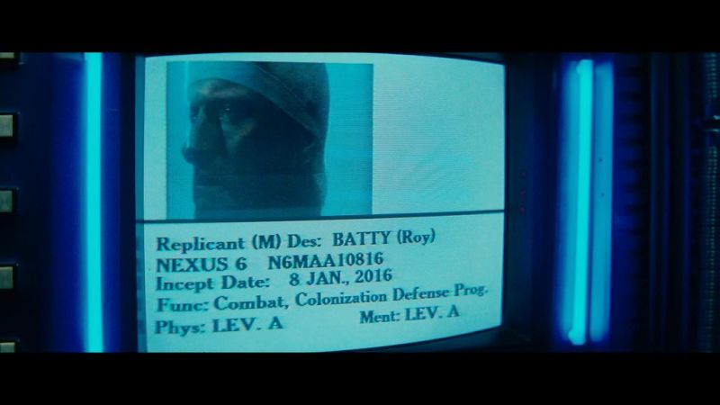

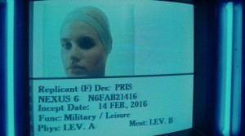

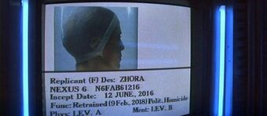

Gaff’s origami

